H.T No
Regulations:
A19

Sreenidhi Institute of Science and Technology
(An Autonomous Institution)
Code No: 7W103 Date: 25-April-2022 (FN)

M.Tech I-Year I-Semester External Examination, April/May - 2022 (Regular/Supplementary)
ADVANCED MECHANICS OF SOLIDS (CADCAM)

Time: 3 Hours Max.Marks:70

Note: a) No additional answer sheets will be provided.
b) All sub-parts of a question must be answered at one place only, otherwise it will not be valued.
c) Missing data can be assumed suitably.

ANSWER ANY FIVE QUESTIONS. EACH QUESTION CARRIES 14 MARKS.

Bloom's Cognitive Levels of Learning (BCLL)
Remember | L1 | Apply | L3 | Evaluate | L5
Understand | L2 | Analyze | L4 | Create | L6

 |  |  | BCLL | CO(s) | Marks
1. | a) | A simply supported beam with overhang is loaded as shown Fig.1. Using the theorem of Castigliano, find the vertical deflection of point C ?  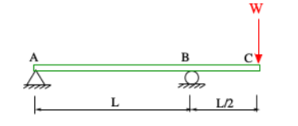  Fig.1 | L3 | CO1 | [7M]
 | b) | Explain the statically determinate and indeterminate structures with case studies | L2 | CO1 | [7M]
2. |  | An I-Section of a beam consists of top flange 140mmX40mm and bottom flange 140mm X 40mm, web 20mm X 220mm. The center line of web is 80mm from the left edge of flange and 60mm from the right edge. Evaluate the shear center of the beam. | L3 | CO2 | [14M]
3. | a) | Derive an expression for the stresses developed in a curved bar of circular cross section when it is subjected to a tensile load. Explain each parameter including units. | L4 | CO3 | [7M]
 | b) | Indicate the formula for position of neutral axis as per Winker-Bach theory and explain each term with a suitable neat sketch | BL-2 | CO3 | [7M]
4. | a) | A shaft transmits 220KW of power at 140 rpm.  i. Determine the diameter of the solid shaft,  ii. The inner and outer diameter of a hollow circular shaft if the ratio of the inner to the outer diameter is 3/4.  iii. The percentage saving in the material on using hollow shaft. Take the allowable stress as 90MPa and density of a material is 84KN/m³. | L3 | CO4 | [6M]
 | b) | Give the procedure to analyze a thin rectangular member subjected to torque T. | L2 | CO4 | [8M]
5. | a) | Explain how to solve buckling problem by using energy method with one case study. | L2 | CO5 | [7M]
 | b) | An aluminum column of length L and rectangular cross-section has a fixed end at B and supports a centric load at A as shown in Fig.2. Two smooth and rounded fixed plates restrain end A from moving in one of the vertical planes of symmetry but allow it to move in the other plane. Determine the ratio a/b of the two sides of the cross-section corresponding to the most efficient design against buckling.  L = 20mm. E = 80GPa P =22KN FS = 2.5  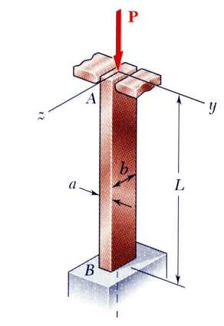  Fig.2 | L5 | CO5 | [7M]
6. | a) | Derive an expression for plane stress and plane strain using Griffith‟stheory | L4 | CO6 | [7M]
 | b) | Explain the LEFM fracture based approach to estimate the fatigue life | L2 | CO6 | [7M]
7. | a) | Describe Maxwell reciprocal theorem. | L2 | CO1 | [5M]
 | b) | How will you calculate the stress due to unsymmetrical bending? | L2 | CO2 | [5M]
 | c) | Investigate where the neutral axis lies in a curved beam. | L4 | CO3 | [4M]
8. | a) | Explain the saint venant’s semi-inverse method with one case study. | L2 | CO4 | [5M]
 | b) | Enumerate the elastic stability of a column and also write the how to avoids the buckling failure of column? | L2 | CO5 | [5M]
 | c) | What are the three modes of loading in fracture mechanics? Explain with neat sketches. | L2 | CO6 | [4M]

-- 00 -- 00 –

